S&M-CM/162/New Plans and Promotions/11-12/34 dt @ Chennai 16-07-11

Sub: Clarification on special “Jai Jawan” pre-paid plan and “Rakshak” post-paid plan under mobile services
Ref : 1. Corporate letter No. 26-14/2011-T&C-CM Circular T&C-CM No. 14/11-12 Date: 19-05-2011 & No.26-18/2009- R&C (Pt) dt 08-0-11
2.This office ltrs of even no. 9 dt 20-05-11 and S&M-CM/163/New Plans and Promotions/Postpaid/11-12/03 dt @ Chennai-6 the 06.04.2011

Field queries are raised in the JaiJawan(Prepaid) and Rakshak (Postpaid) plans. The necessary clarifications are given as detailed below.
Queries | Clarifications
i) Whether top-up voucher is allowed for increasing usage value under Jai Jawan plan? | i) Yes. The customer of Jai Jawan plan can use  all top-up vouchers for increasing the usage  value only and no validity will be extended. For  extension of validity, special RCV of Rs.97 is to  be used, with which the customer will get 30 days  validity and usage value of Rs.73.
ii) Whether the customer of Jai Jawan plan can use all STVs? | ii) Yes, the customer of Jai Jawan plan can use  all STVs currently available
iii) Whether Jai Jawan/Rakshak Plan can be extended to Retired personnel/ Exservicemen also? | iii) No, this facility is available for serving  employees only.
iv) Whether this plan is applicable to State Armed Forces? | iv) No. As of now, the plan is applicable to  Central Armed Forces only
v) What is the alternative document which can be accepted if photo copy of Identity Card can’t be submitted by paramilitary personnel due to security reason? | v) In case photocopy of the Identity Card can’t be submitted by the paramilitary personnel, then the Officer In-charge should certify the official & attest the photograph.

This is for the information of all concerned please.
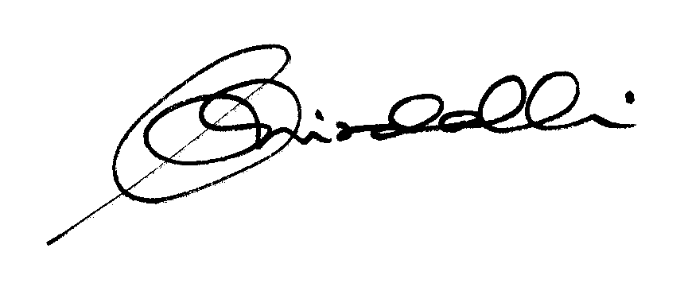

(K.R. Aravindavalli)

AGM(Marketing-CM)

044-28290825, 9443100876

To
GM (NW-O CM), Trichy -1/ Coimbatore – For information & necessary action please.
GM(S&M-CM), Chennai Telephones, Chennai – For information please.
GM (F) / Sr. GM (TR) TN Circle, Chennai for information please.
DGM/DE In charge IN - Trichy - for necessary action please.
DGM (N/W-O)/DE Commercial Coimbatore - For information & necessary action please.
Heads of SSAs, -- for kind information and necessary action please.
DGM (Sales) & AGM (Sales), Chennai-6 –For information and informing Sales Heads , franchisee managers and retail managers and other Channel partners along with commission structure as applicable.
DGM (CS), Chennai-6 - For information and informing Call Centre/Customer Service Centre Officials and ensure uploading the information on the website “tamilnadu.bsnl.co.in” .
DGM(S&M-CM)/AGM (Mktg-CM), Chennai Telephones, Chennai – for information & necessary action please

